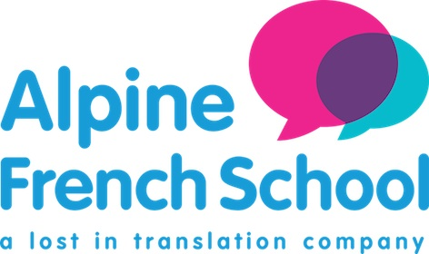 | MONDAY | TUESDAY | WEDNESDAY | THURSDAY | FRIDAY
9h-12h30 | FRENCH CLASS | FRENCH CLASS | FRENCH CLASS | FRENCH CLASS | FRENCH CLASS
13h30 - 15h | SCAVENGER HUNT | SWIMMING POOL  BEACH VOLLEYBALL  (back at Flocons 4.30pm)  Option + | DERECH QUEST  Option+ | HIKE TO SEE MONT BLANC  or  TREASURE HUNT | QUIDICH TOURNAMENT  Option +
15h -16h | WATER GAMES/OLYMPIC GAMES |  | TENNIS | KITCHEN WORKSHOP
16h - 17h30 | CABIN BUILDING | TENNIS  or  CHEESE RACE | PETANQUE | BODY PAINTING | BOARD GAMES

